CHAPTER 3: Evolution
Worksheet 3.1

Struggling to survive
Student: Class:
1. Define the term ‘adaptation’.
Adaptation: a special characteristic that helps an organism survive and reproduce in its environment

2. Explain how each of the following examples are adaptations for survival.
(a) Desert marsupials excrete small quantities of very concentrated urine.
Expelling only small amounts of concentrated urine helps to retain water in the body and avoid dehydration in the harsh desert climate.

(b) Polar bears have a thick fur coat.
The thick fur helps to retain heat and thus avoid hypothermia in the icy environment.

3. Blackberries and cane toads are introduced species in Australia.
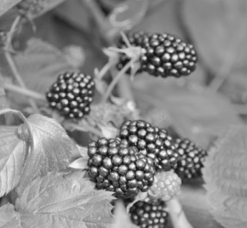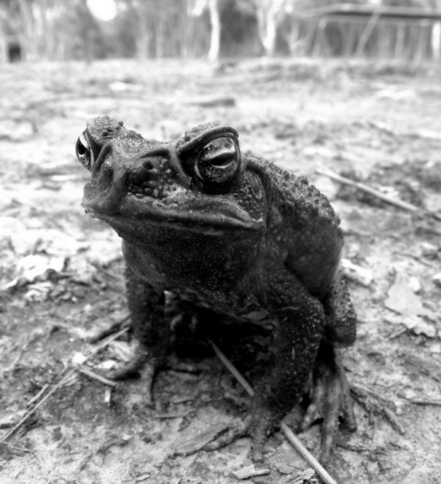
Photos:
Blackberries: digifuture/123RF
Cane toad: Hypervision Creative/Shutterstock.com
(a) Blackberries were introduced to Australia in the 1800s and have spread across the landscape and taken over various habitats. Explain why this plant has successfully outcompeted native species.
Blackberries are robust and outgrow native species, which they smother. They produce many seeds in berries that are eaten by animals and dispersed far away from the parent plant. The plant also grows vegetatively and spreads quickly.

CHAPTER 3: Evolution
Worksheet 3.1

Page 2

(b) Cane toads were introduced into Queensland to control sugarcane pests. The toad in turn has become a pest and has spread into NSW and the Northern Territory. Explain why the cane toad has been able to invade large areas of land.
The toad has no natural predators and so its numbers cannot be naturally controlled. It has poison glands that cause predators to die. It has adapted well to the tropical environment of northern Australia.

4. The Asiatic black bear constructs beds and platforms in trees and eats nuts, fruits and small animals.
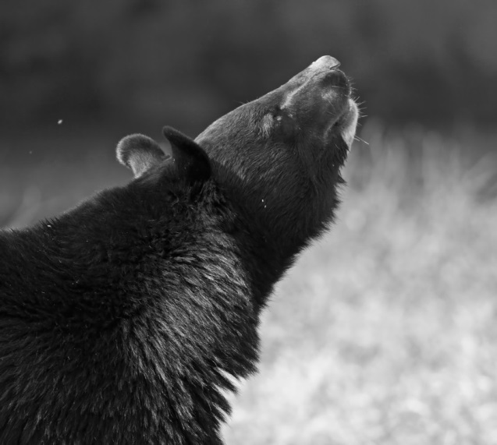
Photo: wildlywise / Shutterstock.com
Describe structural adaptations that the Asiatic bear has in order to survive in its habitat.
The Asiatic bear has strong forelimbs and sharp claws that are suitable for climbing trees. Its ability to climb trees ensures that it can eat nuts and fruit.

